
ReGeneration
Consulting, Inc.
Solving today’s problems using tomorrow’s solutions

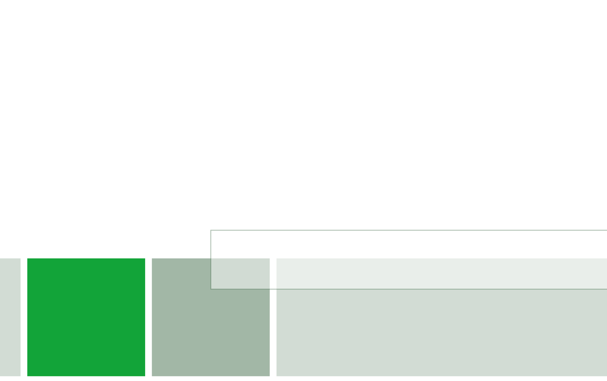

Sustainable Building and LEED National Problem Statement

ASC Student Competition 2015
Sparks, Nevada





PROBLEM STATEMENT 1: LEED 2009 vs LEED v4 ASSESSMENT
PART 1: OVERALL PROJECT REVIEW
LEED 2009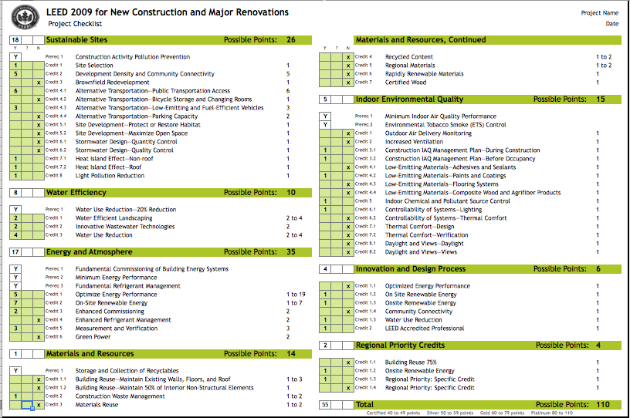
LEED V4
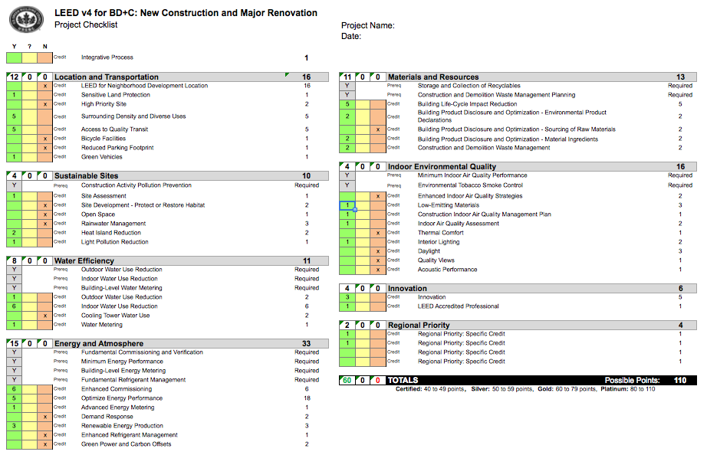

PART 2: MATERIALS CATEGORY
The proceeding information is a breakdown of the major differences in documentation and compliance between LEED 2009 and LEED V4 pertaining to the materials category.
MECHANICAL, ELECTRICAL, & PLMBING INCLUSION
LEED V4 includes passive products of MEP systems in its calculations while LEED 2009 does not.
Advantages: The optional assessment of MEP products gives the client additional materials or “chances” to qualify for LEED credits. For example, the client may aid their efforts in achieving the materials credit of Building Product Disclosure and Optimization- Environmental Product Declarations (1-2 points) through selecting a section of ductwork with life-cycle information that has environmental, economic and socially preferable life-cycle impacts.
Disadvantages: As the clients search, procurement, and installation of MEP systems relate more to LEED it will take more time and money to research and schedule system installation/ inspections for these systems.
COMBINATION OF CREDITS
LEED V4 combined multiple old credits from LEED 2009 into a single credit. This applies to the V4 credits of Building Life Cycle Impact Reduction and Building Product Disclosure and Optimization – Sourcing of Raw Materials. The Building Life-Cycle impact Reduction credit from V4 is a combination of the LEED 2009 credits Building reuse-Maintain Walls, Floor and Roof and Building Reuse-Maintain Interior Nonstructural Elements. Similarly, the V4 credit of Building Product Disclosure and Optimization – Sourcing of Raw Materials is a combination of the LEED 2009 credits Recycled Content, Regional Materials, and Rapidly Renewable Materials.
Advantages: In regards to the V4 Building Life Cycle Impact Reduction credit: the credit simplifies documentation for structural and non-structural calculations. Additionally, through the required documentation of a Life Cycle Analysis, the project will diminish environmental hazards such as global warming potential or the depletion of the stratospheric ozone layer thus, improving public health and the environment. In Regards to the V4 Building Product Disclosure and Optimization– Sourcing of Raw Materials Credit: certain aspects of this credit have been made easier to achieve than its 2009 counterparts due to the reduction in requirements. For example, pertaining to the LEED 2009 credit of Regional Materials, the 500-mile radius requirement was decreased to 100 miles
Disadvantages: In regards to the V4 Building Life Cycle Impact Reduction credit: the total points possible have been reduced. The summation of the points awarded from the two LEED 2009 credits equals 4 while the LEED V4 only provides 3 points for New Construction. Also, the V4 credit requires more documentation; therefore, it requires more time and money to complete. Additionally, this makes this credit harder for the owner to achieve. In regards to the V4 Building Product Disclosure and Optimization – Sourcing of Raw Materials Credit: Certain Aspects of this credit have become harder to achieve due to increased criteria. For example, the requirements from the Recycled Content Credit (LEED 2009) have been coupled with additional requirements to form a single option. This causes this option to become harder to achieve due to the additional stipulations.
NEW CREDITS
LEED V4 created new credits for the Materials Category. The new credits added to LEED V4 are as follows; the pre-requisite of Construction and Demolition Waste Management Planning, the credit of Building Product Disclosure and Optimization- Environmental Product Declarations, and the credit of Building Product Disclosure and Optimization- Material Ingredients.
Advantages: The Construction and Demolition Waste Management Planning Pre-Requisite sets the owner up for success with the Construction and Demolition waste Management Plan credit in the Materials category. The pre-requisite forces the owner to draft a CWP plan, which is required to be implemented in the proceeding credit. Also, the addition of credits gives the owner more chances to obtain more points. For example, the Building Product Disclosure and Optimization- Environmental Product Declarations credit will award the owner 1 to 2 points for achieving the credit.
Disadvantages:The addition of a pre-requisite adds barriers for owners to achieve any credits from the materials category.
PART 3: RECOMMENDATION OF RATING SYSTEM
Per our scorecards in Part 1, ReGeneration Consulting would recommend that the owner pursue LEED V4 Gold. We here at ReGeneration Consulting believe that the LEED V4 rating system should be used because it utilizes the most current green building standards. Additionally, we have calculated that by pursuing LEED V4, the project will be able to obtain a Gold certification. Whereas with the LEED 2009, the project would only receive a Silver certification. Please see below for our list of assumptions dealing with the ability to receive credits:

ASSUMPTIONS:
Location & Transportation / Sustainable Sites: Due to the location of the project, we were able to get many credits for both 2009 and V4 due to the local surroundings density. Furthermore, we believe aspects such as heat island effect and light pollution reduction are very obtainable.
Water Efficiency: Because of the use of rainwater we got both points for outdoor water use reduction in 2009 and 1 point in V4. Due to our use of a composting toilet we achieved Innovative Wastewater Technologies in 2009. Our use of highly efficient bathroom fixtures allowed us to achieve max points in both 2009 & V4.
Energy & Atmosphere: For both scorecards we utilized the fact that we believe we can achieve a 20% energy reduction. Additionally, due to RFI 22 stating that we need to be net zero energy, we achieved all points for on-site renewable energy. We also will work to have metering and enhanced commissioning for the project.
Materials and Resources: For LEED V4 we believe that almost all of the credits are available to us because we believe that we can obtain the necessary documentation. However, because of the way 2009 is formatted, we were only able to get one credit for this category.
Indoor Environmental Quality: Due to the bathroom facility, we believe that we can achieve the credits denoted on both scorecards. However, due to the lack of other buildings, the rest of the credits in this category were not available to us.
Innovation: We assumed we can achieve half of the innovation credits for 2009 and V4 and that there is a LEED AP.
Regional Priority: We assumed that we can achieve 3 regional credits for V4 and we will receive all but 75% building reuse for 2009.

PROBLEM STATEMENT 2: LIFE CYCLE SUSTAINABILITY ANALYSIS-LIGHTING

PART 1: ANNUAL ENERGY USE
PART 2: LIFE CYCLE ANALYSIS
Criteria:
Sustainable innovations calculated the 10 year life cycle based on the following criteria.
Cost of Supply and Install ,Cost of maintenance, Determine the number of lights at Colorado/ 4th St Station, Determine the number of times the lamp needs to be replaced, Yearly maintenance required, Overhead Maintenance
Profit Margin, Construction Fee, Design Fee Lump Sum, Warranty Period
Design Fee, Average lifespan of Fluorescent and LED lamps
Formula:
- Determine cost of Supply and install and # of Lights
- Multiply to find Base cost of lights
- Sum base cost of each light type into total cost of lights
- Determine the life span of Fluorescent and LED lamps [24,000 hrs. -Florescent lamp, 50,000 hrs.- LED]
- Find number of times each lamp will need to be replaced in a 10 year period
- Add in assumed yearly maintenance
- Subtract time from 10 year period based on the length of the warranty for each subcontractor
- Add in additional fees [Construction, profit, design, overhead]
PART 3: SUBCONTRACTOR SELECTION
ReGeneration consulting recommends McKinstry as the subcontractor for Colorado/ 4th St Station lighting. We chose Mckinstry because our estimates showed that they had the lowest 10 year life cycle cost in both Fluorescents and LED’s. This was due mainly to the 3 year warranty which guarantees free maintenance on all supplied material.
Assumption: As stated in the Mckinstry Lighting Bids in the inclusions section it states “manufactures warranty applies to Mckinstry supplied material”. We assumed that this included lamps that would burn out within the 3 year period.
PART 4: INCENTIVES & REBATES
Southern California - Non-Residential Energy Efficiency Programs
Offers incentives for LED Lighting Utility rebate program. Additionally the rebate can be applied to state run projects. The rebate states that the rebate amount varies widely based on the type of lighting.
Incentives Include:
Maximum Incentive: Standard Performance Contracting: 50% of Cost . Customized Solutions: Up to 50% of contract Direct Install Program: $10,000
*Contracting program in which non-residential users have the option of designing an energy retrofit conservation measure. Incentives are based on the type of measure installed and the kWh saved and peak demand reduction over a 12-month period. Applicants are eligible to receive up to 50% of the cost for each measure type. The maximum incentive is $2,400,000 annually, per customer site.
Savings by design (SBD)
Offers incentives for High efficiency products in new construction. It is administered by the Pacific Gas and Electric Company. Eligible projects must be within new construction, pay utility bills within the certain municipalities, and be in design phase where changes are feasible.” Incentives are limited to 75% of the incremental cost of the efficiency upgrades”. The standard method of determining incentives is through $ per kWh savings based on peak performance. Exterior lighting would fall under “Other Systems and Processes”
.

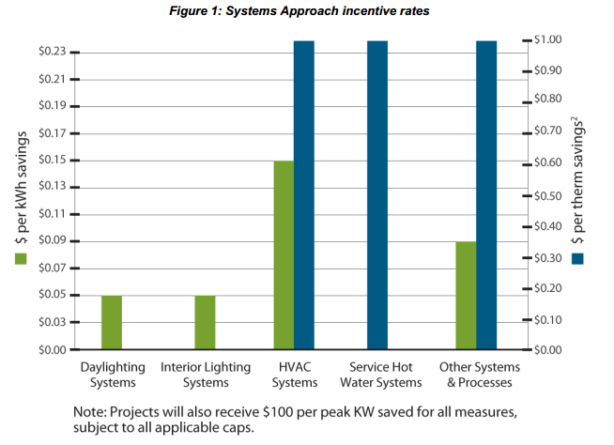

Commercial Lighting Incentive Program by Los Angeles Department of Water and Power
Open to LADWP non-residential electric customers in good standing. Qualifying equipment must have received LADWP approval prior to purchase, installation and operation. The project must achieve a minimum of 10% energy savings. Although the LED lights alone will not fulfill the 10% energy savings, other methods can be implemented into the project to achieve the 10% energy savings.
If achieved the incentive program promises .15 cents per kWh of annualized savings

PART 5: INCENTIVES & REBATES
Based on the above analysis we would recommend LED lights. While a substantial amount of paperwork and collaboration with the above programs the rebates and incentives would prove worthy.
If the Colorado 4th street station is approved for the Southern California - Non-Residential Energy Efficiency Programs it can expect a high rebate. Simply because the program is based off of the number of kWh that are saved every year and based of our estimates we can expect 15301 kWh saved each year.
If the Colorado 4th street station savings by design program claims to offer .3 cents saved per kWh annually. This would allow rebates of $1377.09 annually.
If the Colorado 4th street station is approved for the Commercial Lighting Incentive Program by Los Angeles Department of Water and Power the choice to implement LED’s can lead to rebate of $2295.25 due to the .15 cents per kWh saved.
If one of these were approved the additional cost to implement LED’s would not only be offset but would help pay off the 10 year life cycle cost of the LED’s themselves. Our best estimate came from the Commercial Incentive Program by LADWP, if $2295.25 were reimbursed to the State for 10 years the expected return would be $22,950. Based on the 10 year cost analysis with Mckinstry the LED’s would prove to be $18,707 cheaper at the end of the 10 years.

PROBLEM STATEMENT 3: CONCRETE CARBON FOOTPRINT
Part 1: BID COMPARISON
1.) The total cubic yards required for the 4th Street Station is 1101.2654 (this includes 7% additional concrete, beyond neat line quantity) which would then be rounded to 1102 total yards (due to being unable to order partial concrete yards). This number is based off of the cubic yard totals in attachment #7 from all 4th Street Station concrete totals.
2.) The total price for each supplier is listed below. The cheapest supplier, based on the number of concrete yards calculated was City Park Concrete.
City Park Concrete - $72,154.72
White Castle Concrete - $72,780.99
Slip Diamond Ready Mix - $85,483.01
Assumptions: Total truck loads: 111 (110 regular, 1 short)
No sales tax was included in the calculation; the total concrete yards with the 7% additional concrete was used to calculate the number of truck loads; used standard 10 cubic yard concrete truck for calculations.
3.) The carbon footprint of each supplier is based on the locations we found in attachment #8 for each material source and supplier. When ReGeneration Consulting had to choose a specific location we went with the location that had the shortest distance. The reason we went with shorter distances was because of the amount of heavy traffic that the project area experiences which would ultimately raise the carbon footprint. We came to the conclusion that City Park Concrete had the lowest carbon footprint based on the travel distance carbon footprint we calculated. However, if we take into consideration the use of fly ash and how many emissions are saved by using this recycled byproduct, then we would select White Castle Concrete due to its’ one-to-one ratio of fly ash to cement (345 lbs. to 345 lbs.).
White Castle Concrete – 505 Railroad Place, Inglewood, CA 90301
Batch ---to--- Project = 11 miles
Aggregate: Polaris Materials Corp. – Port McNeill, BC, Canada = 1543 miles
Cement: Cemex – Already at location = 0 miles
Fly Ash: Headwaters Resources – 1345 Philadelphia St., Pomona, CA 91766 = 43 miles
Total Miles (source to batch to plant) = 1597 miles
Carbon Footprint:
1597 miles / 5.5 mpg = 290.36 gallons
290.36 gallons x 22.38 = 6498.34 pounds of Carbon Dioxide (3.25 tons)
Slip Diamond Ready Mix – 519 S. Benson Ave., Ontario, CA 61762
Batch ---to--- Project = 53 miles
Aggregate: Saticoy Recycled – Oxnard, CA = 95 miles
Cement: Standard Ready Mix – 2130 S. Grand Ave., Santa Ana, CA 92705 = 33 miles
Fly Ash: Salt River Materials Group – 13600 Napa St., Fontana, CA 92335 = 12 miles
Total Miles (source to batch to plant) = 193 miles
Carbon Footprint:
193 miles / 5.5 mpg = 35.09 gallons
35.09 gallons x 22.38 = 785.33 pounds of Carbon Dioxide (0.39 tons)
City Park Concrete – 11122 W. Pico Blvd., Los Angeles, CA 90064
Batch ---to--- Project = 4 miles
Aggregate: Vulcan Materials, San Gabriel Valley, CA 91776 = 29 miles
Cement: CalPortland Concrete Products, 519 S. Benson Ave., Ontario, CA 91762 = 48 miles
Fly Ash: No fly ash in mix = 0 miles
Total Miles (source to batch to plant) = 81 miles
Carbon Footprint:
81 miles / 5.5 mpg = 14.73 gallons
14.73 gallons x 22.38 = 329.6 pounds of Carbon Dioxide (.16 tons)
Assumptions: To do the carbon footprint we used a transportation semi-truck that averaged 5.5 miles per gallon. We also used 22.38 pounds of carbon dioxide per gallon of diesel.
Source: http://www.eia.gov/tools/faqs/faq.cfm?id=307&t=11

4.) The best value supplier based on the calculations that we ran is City Park Concrete because they were not only the cheapest, but also had the least amount of CO2 emissions based on transportation distances.
Equation = Question #2 pricing + (Question #3 tons of carbon x $40) + (total yards of concrete x $40) = Total Updated Price
City Park Concrete - $72,154.72 + (3.25 x $40) + (2290.63 x $40) = $80,971.44
White Castle Concrete - $72,780.99 + (.39 x $40) + (2095.71 x $40) = $81,721.08
Slip Diamond Ready Mix - $85,483.01 + (.16 x $40) + (2236.78 x $40) = $94,308.84
Assumption: We went with the assumption that 400 pounds of Carbon Dioxide were produced per cubic yard when being manufactured.

Part 2: LOCAL vs. OUT OF TOWN LABOR
1.) The total carbon footprint is 4.623256 tons (9246.512 pounds) carbon dioxide. Based on an assumption of 19.64 pounds of carbon dioxide are produced per gallon NOT containing ethanol.

Source: http://www.eia.gov/tools/faqs/faq.cfm?id=307&t=11

2.) The total carbon footprint will be reduced from 4.623256 tons (question 1) to 1.13421 tons. This is a total reduced savings of 3.489046 tons of carbon dioxide. This is assuming the laborers live at a distance of exactly 15 miles.

3.) The total carbon footprint would be reduced from 4.623256 tons (question 1) to 2.10639 tons. This is a total reduced savings of 2.516866 tons of carbon dioxide.

FIGURES:
FIGURE 3.1
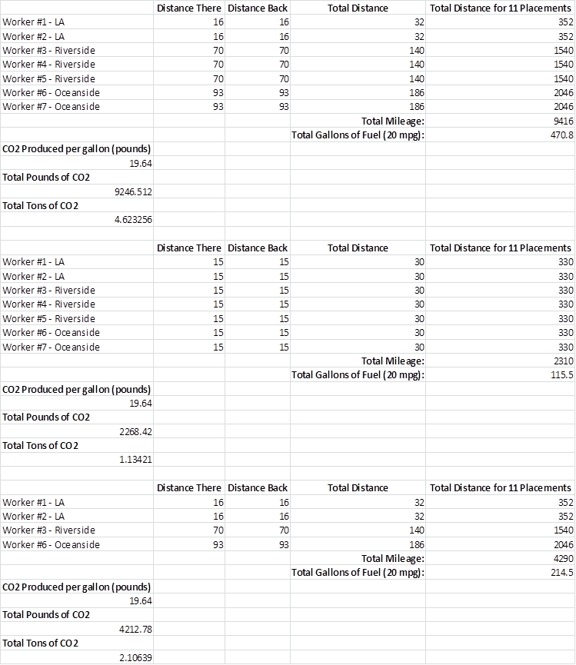
FIGURE 3.2

PROBLEM STATEMENT 4: WATER COLLECTION AND USAGE
PART 1: IRRIGATION CONSUMPTION
In order to find the total water usage my month for the landscaping at the fourth street station, ReGeneration Consulting first had to determine the local reference evapotranspiration per month. Once this was determined, we were able to multiple this number by the plant coefficient provided to us. This number gave us the landscape evapotranspiration per month. This number was then multiplied by the irrigation efficiency which gave us our total water to be applied in inches per square foot. Because an irrigation efficiency was not called out in the contract documents, we researched the type of sprinkler called out for in the contract drawings and through our research came up with an efficiency of 85%. This assumption was applied to each month. Once we had found the total water to be applied per month, we converted it from inches to gallons per square foot needed and then multiplied that by the total square footage of landscape to find the total water needed in gallons to water the plants per month. Please refer to figure 4.1 to find our math related to this question and the final totals broken out per month in bold.
References:
http://www.water.ca.gov/wateruseefficiency/docs/wucols00.pdf
http://www.usclimatedata.com/climate.php?location=USCA1024
PART 2: RAIN WATER COLLECTION
In order to not use potable water for landscaping at any point during the year, the owner would need to install a 69,078 gallon tank so that the tank could supply water to the landscaping throughout the dry months of April through October. Please refer to Figure 4.2 to find our math related to this question.
PART 3: CISTERN
To determine the capacity of an onsite cistern and how much supplemental water would be required by month, ReGeneration Consulting started by taking the dimensions of the bike storage area on the north-west corner of the transit center and found it to be 33’x26’. The problem statement called for a max excavation of 12’ and concrete walls of 1’ on both vertical and horizontal concrete placement. This left us with a tank of 31’x24’x10’ or 7440 cubic feet. Converting this to gallons, we found that our water storage tank would be 55655.06 gallons.
To answer the second part of the question, ReGeneration Consulting took the amount of water needed to make it through the dry season, 69078.31 gallons, found in Part 2 and subtracted that by the size of our cistern found in Part 3.A, 55655.06 gallons. We found that we would be short a total of 13423.24 gallons and that the only two months we would have to supplement the cistern would be 7969.54 gallons in September and 5453.704 gallons in October.
FIGURES:
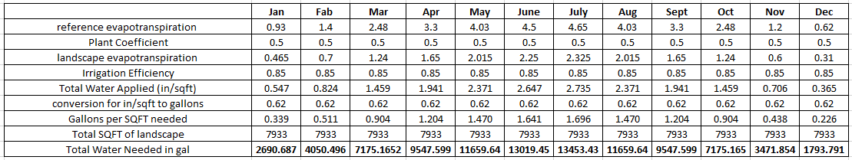FIGURE 4.1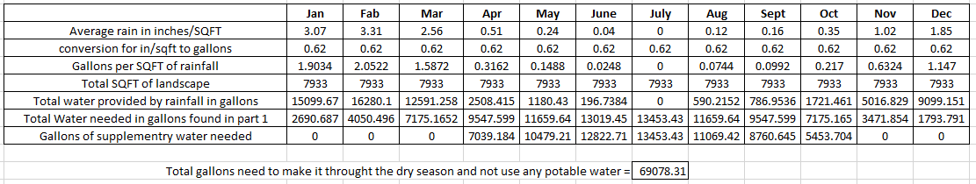
FIGURE 4.2
PROBLEM STATEMENT 5: ON-SITE RENEWABLE ENERGY
PART 1: SOLAR PANEL DESIGN
After carefully studying all three solar panel options, ReGeneration Consulting, Inc. recommends choosing the Sunpower X21-345W solar panels. We came to this conclusion based on a number of factors. The X21s provide the most energy output even after considering both the performance ratio of 75% due to shading and the performance depreciation after 25 years. Sunpower offers the best warranty option with the least performance depreciation. The performance depreciation is based on the warranty information given within the cut sheets provided by the vendors. In addition, these panels were also the most efficient. Other factors that we considered include:
- 44% more power per panel
- 75% more energy per square feet over 25 years
- 8-10% more energy per rated watt
- 21% more energy over the first 25 years than conventional panels

The most influential information was the total cost of the system and the amount of panels needed. Due to the limitation of usable roof area, the X21s are the best option. The owner would only need a total of 9 panels to offset 8% of the total output energy of the C/S and TOS buildings. The total cost of this system would be a feasible $4,185. The X21s ranked #1 in numerous categories that we studied while providing the best value to the owner. They stood out significantly from the other two available choices. For all of the reasons above, we strongly recommend Sunpower’s X21-345W panels for the proposed 4th St. Station.
To maximize the amount of sunlight captured by the panels based on the latitude of the proposed location, the panels should be oriented directly south throughout the year with a magnetic declination of 14° east. We recommend using a tilt angle of 58° for the winter months and 10° for the summer months. The dates that the panels should be adjusted are April 18th for the summer and October 7th for the winter. This will maximize the efficiency of the system while providing the quickest payback period for the owner. See attached documents for further information. 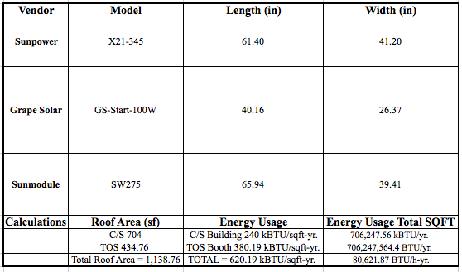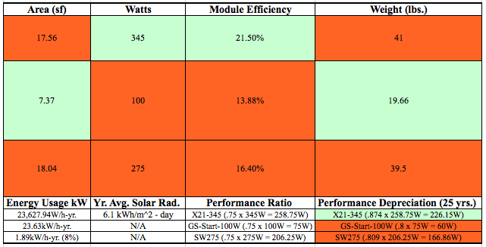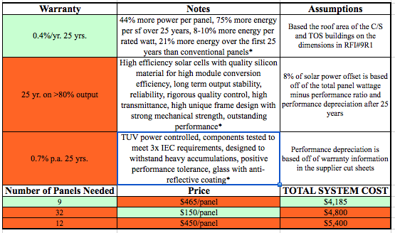
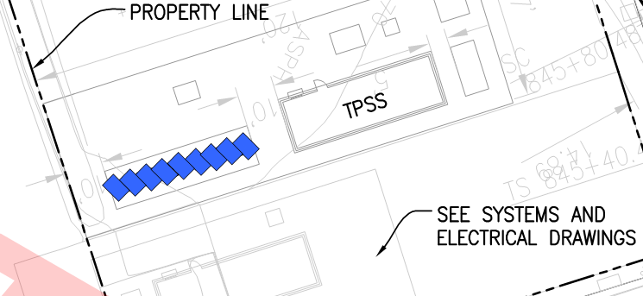
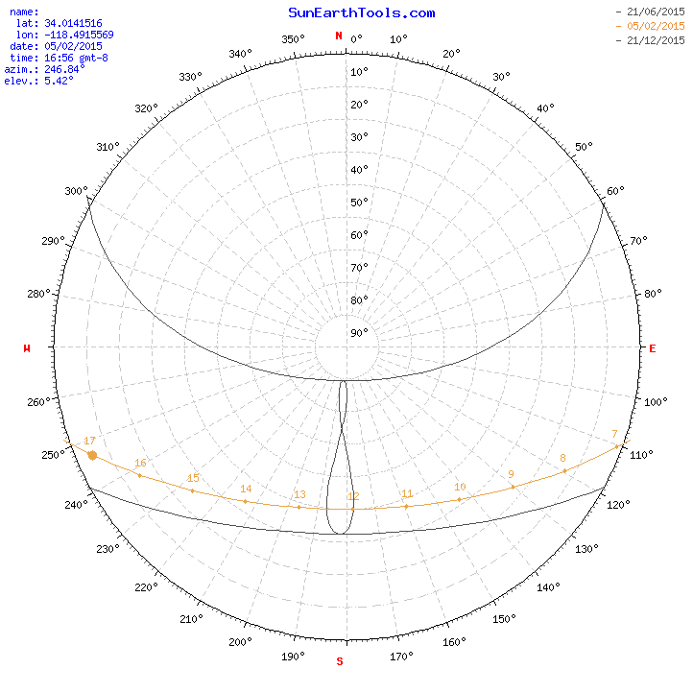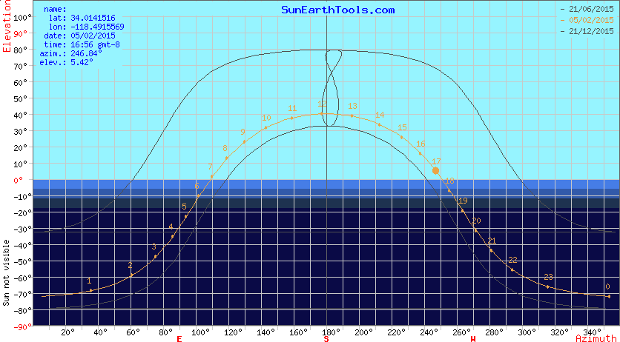
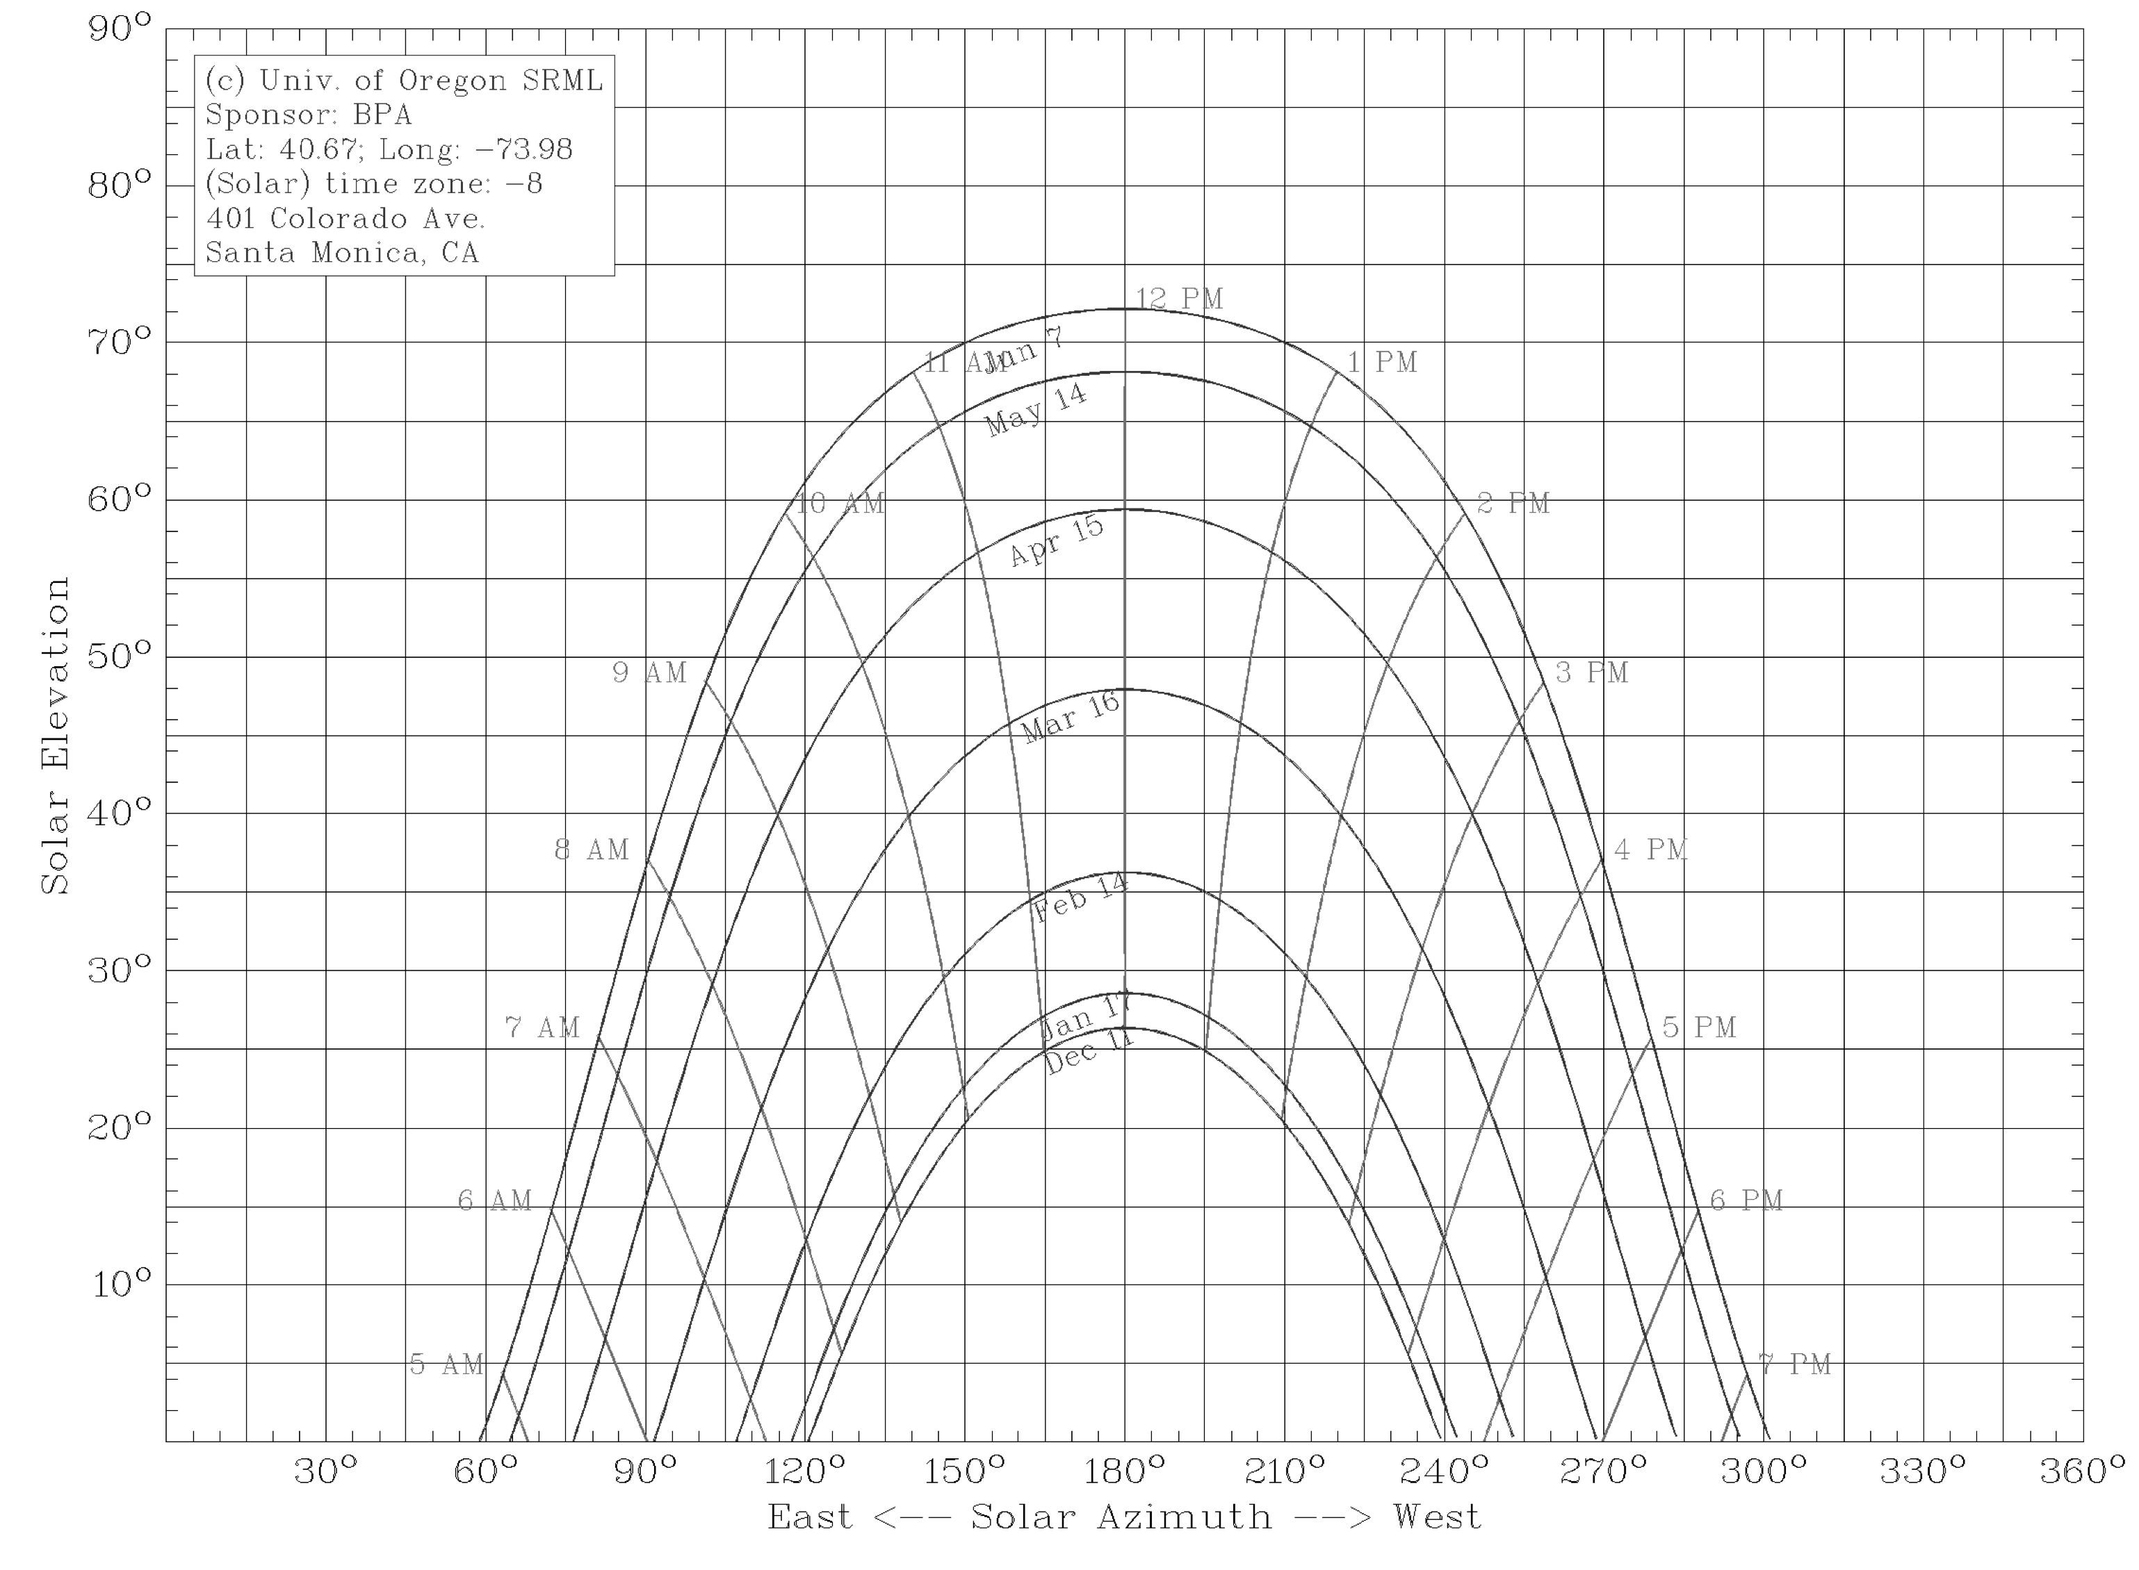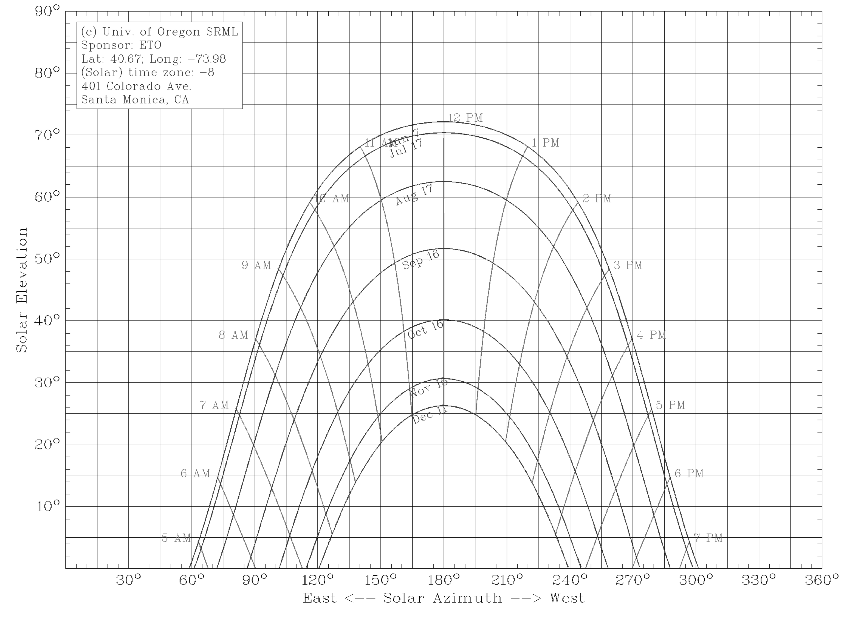
PART 2: ADDITIONAL RENEWABLE ENERGY-OPTIONS TO NET ZERO
To achieve the client’s requested Net Zero Energy for this portion of the project, ReGeneration Consulting, Inc recommends using the SunPower X21-345 on the small (~4 acre site), which is 50 meters from the project site. In Figure 5.7, it became apparent that this was the cheapest and most efficient option of all three. The price of each of these solar panels is $465.
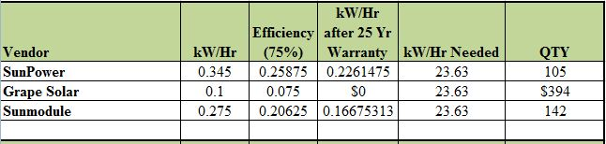
The total cost of a 105 system comes to $113,470, based on the calculations found in Figure 5.8. We assumed this would be a stand alone system and because it is essential that the station constantly has power, therefore we are incorporating a generator into the costs.
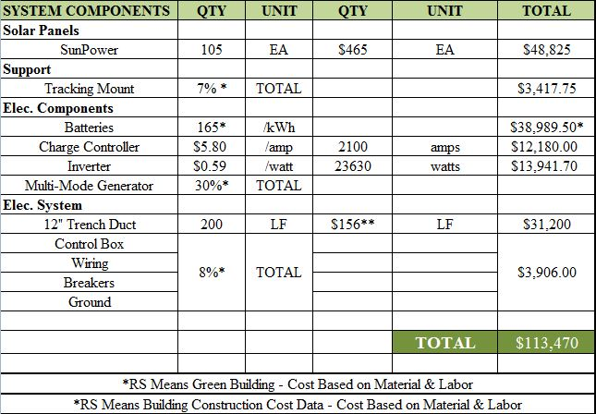

Based on the calculations shown in Figure 5.9, it would take approximately 26 years to payback the total cost of the system. This was calculated based on the assumption of an average of 4 hours of sunlight per day. Because this system is projected to last for 40 years, we feel this system would long outlast the payback period.
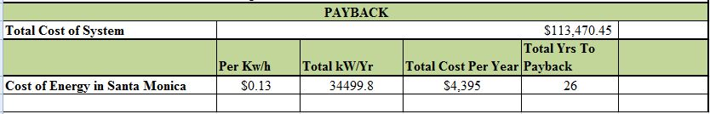
Based on the average cost of annual maintenance it would be around $2040 per year.

PART 3: ALERNATIVE RENEWABLE ENERGY SOURCES
To meet the energy needs of Santa Monica’s new transit center at the corner of Colorado Ave and 4th Street, we explored four renewable energy options for the site. The four options include a biofuel based electrical system, geothermal energy system, hydroelectric power system, and micro wind turbines. To begin, we explored the option of placing a biofuel based electrical system on site. We found this technology to be a great option and one that could provide a significant amount of power to our site. However, we quickly found several noticeable flaws. The first being that you would have to truck in the material to be processed. Trucking in fuel would not only have an associated cost, but would also have a carbon release that would be detrimental to the environment. However, not only would trucking in material have a carbon release, so would the plant. Lastly, in order to run a plant you have to have someone working it which would be an added cost for the station. So although we feel this is a great technology, we do not believe it is one to be considered for this project.
One such system we believe could be a better option is a geothermal energy system. A geothermal energy system is a viable option and could provide a significant amount of power to our site. However, it too has several downfalls. The first being that the size of the lot does not allow for very many wells to be drilled, thus reducing the systems potential. Secondly, because geothermal systems are very expensive it would add a large cost to the project. Lastly and possibly the most concerning issue it that we would be placing a geothermal system very close to an active fault line. We believe that because of the proximity to the fault line and the high risk of earthquakes, installing a geothermal system would not be a wise use of the owner’s money.
This leads us to hydroelectric power system. Because of the lack of a water source on site, we believe such a system would be unrealistic to pursue.
Lastly, we explored the idea of having micro wind turbines on site. This technology excited us the most for a number of reasons. Those reasons include the size of system and being able to include multiple on site as well as the fact that this would be the most carbon natural and environmentally friendly option out of the four we researched. We do have one concern for the system though and that would be the local wind speeds. Our research indicated the average wind speeds in the area to be between 5.5 – 9 mph or 2.5 – 4 m/s. Many of the micro wind turbines we found require at 3 m/s to turn the blades and 5 m/s to have a viable payback period. Although we think this would be a great system, the varying wind speeds throughout the year do not allow this system to max out its full potential and is therefore not beneficial to the owner.
In conclusion, we believe that photovoltaic panels are still the best options for the owner because of the environmental aspects as well as the payback period.
ADDENDUM 1: EXPO DAILY RIDERSHIP
According to the Expo website, the Expo Light Rail line is projected to have 64,000 riders per day.

The Expo Light Rail Line will save 40533.33 Gallons of gasoline per day. To calculate this value ReGeneration Consulting assumed that there was one car per rider and that the cars driven received 24 miles per gallon (MPG based off of a Washington Post article)

An innovative way to increase ridership is to incorporate the surrounding culture into the light rail stations. ReGeneration Consulting proposes that the client does this through providing areas at which local artists can showcase their artwork for two weeks at a time. Another way ReGeneration Consulting proposes that the client increase ridership is through the utilization of Los Angeles Countys’ incentives program for transit riders. This incentives program, which is already in implemented in the county, offers discounts to concerts, sporting events, and museums for regular transit riders.

