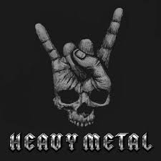
HEAVY METAL, INC

Date: February 4, 2021

To: DPR
Attn: Estimator
Subject: Gene Theory

DPR Construction,

Heavy Metal Inc. is totally psyched to provide the most killer proposal for the following scope of sweet steel: CP-2

- Detailing/Shop Drawings/Engineering - $55, 575
- Embeds/Anchor Bolts - $0
- Structural Framing and Misc. Structural Items - $62, 412
- CMU/CIP Misc. Metals - $13, 600
- Elevators Misc. Metals - $80, 543
- Equipment Anchorage & Support – Excluded
- Miscellaneous Metals - $45, 662
- Standard Railings & Guardrails (Deferred Approval) - $31, 977
- Decorative Railings & Guardrails (Deferred Approval) - $292, 728
~~~ CCIP Deduct per CCIP Manual – Form “B” ~~ $10, 186

Bid Price: $ 572, 311

Add ALT Proposal:

Item # | Alternate Description | Add/Deduct | $ Amount
01 | Remove plate steel, embeds, I-Beams, stainless steel plate curb at site IPE wood bridges from this scope of work. Reference details on sheet 2LC-503. | Deduct | $ (148, 200)
02 | Furnish & Install tree grates with angle frame at locations shown per details 5 & 6/2CL-503 | Add | No Quote
03 | Furnish & install HSS 12x8x1/2 along gridline 401 at level 1 at exterior glass folding doors. HSS to be welded below structural steel beam as noted on 2S-123 and as shown in D3/2A-522 | Add | $ 11,600
04 | Furnish & install typical overhead support for exterior coiling doors at level 1 loading dock/warehouse area (No details shown in drawing) | Add | $ 9, 600

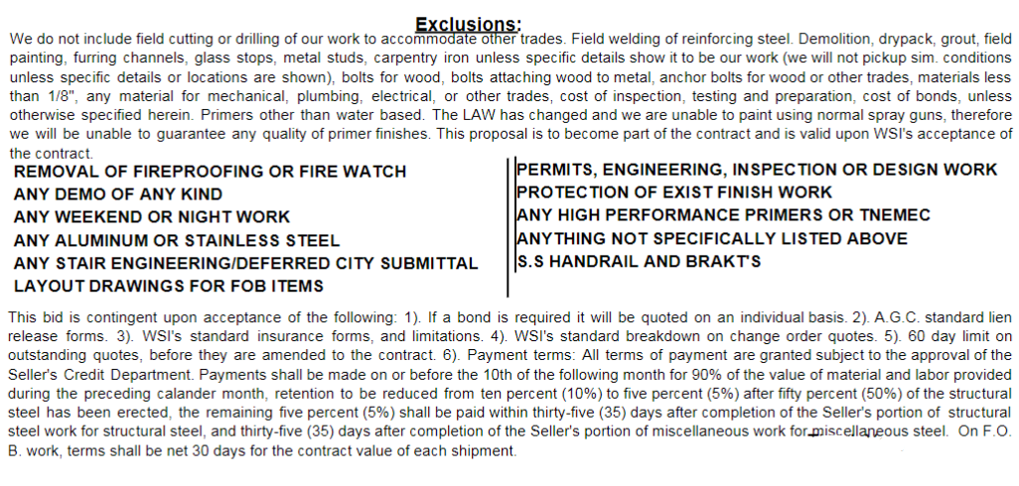

EXCLUSIONS:
3.01 Payment and performance bonds.
3.02 Insurance costs that are covered by the CCIP.
3.03 Prevailing wages.
3.04 Light gauge framing members.
3.05 Concrete reinforcement steel.
3.06 Grouting of base plates.
3.07 Wood blocking and nailers.
3.08 Concrete foundations.
3.09 Structural steel framing at CP-2.
3.10 Metal stairs at CP-2.
3.11 Standard pipe rails at metal pan stair
3.12 Rooftop equipment stands per E3/2A-562
3.13 Lab equipment/overhead carrier anchorage and support at CP-2

Please do not hesitate to call if you have any questions or if you require further information

Sincerely,
Heavy Metal, Inc.

Tommy Lee

